PASSPORT | DESIGN WALL | THE EMPTY BOBBIN | KEYSTONE MODERN CREATIVE
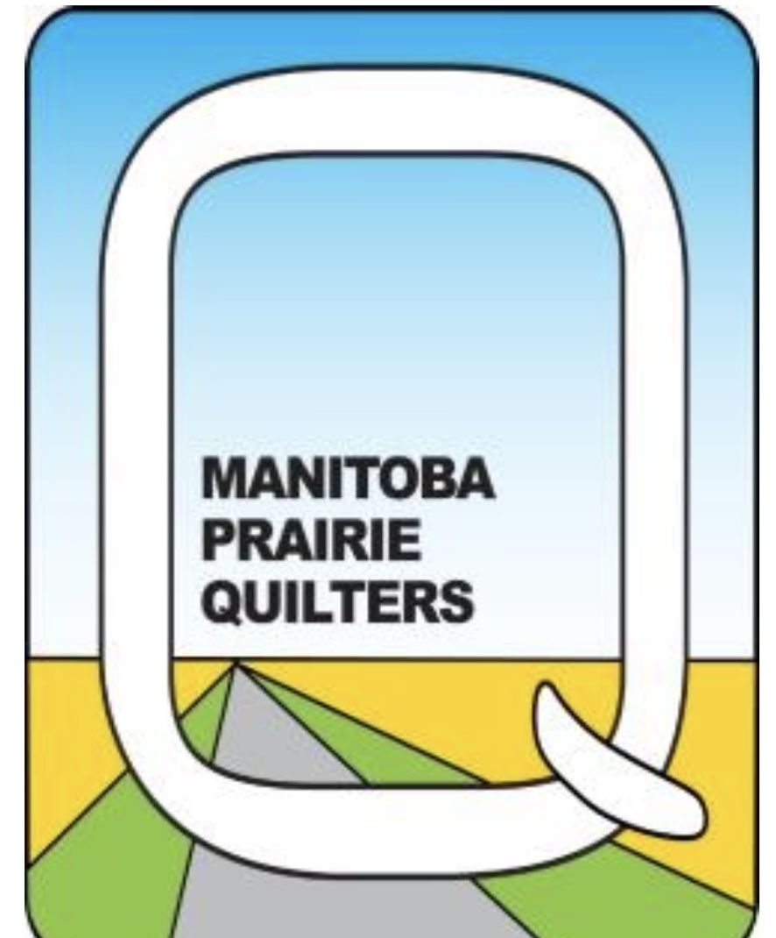 | KTR SEWING CENTRE |  | NEEDLE CRAFTS AND STUDIO
 | SEW PERKS | 2021  Virtual  Shop  Hop | QUILTERS’ DEN

